Requirements Phase Gate

# Revision

Version 6

4/14/25 8:37 AM

# SME

Charles Wilson

# Abstract

This document describes the process used to confirm that all work products specified within the requirements phase are complete, and sufficient to generate the work products required by applicable certification standards.

# Group / Owner

Security / Secure Software Assessor

# Motivation

This document is motivated by the need to have formal processes in place for the verification and sign-off of phase products necessary for the creation of certification work products required for the certification safety-critical, cyber-physical systems, such as **ISO/SAE 21434** and **ISO 26262**.

# License

This work was created by **Motional** and is licensed under the **Creative Commons Attribution-Share Alike (CC BY-SA-4.0)** License.

<https://creativecommons.org/licenses/by/4.0/legalcode>

# Overview

The requirements phase gate provides a point of process synchronization for all organizational groups to confirm that their process requirements have been fulfilled. The outcome is either a passing of the gate (transition to the design phase) or failure to pass (required products are incomplete).

The following diagram illustrates the process to be used:

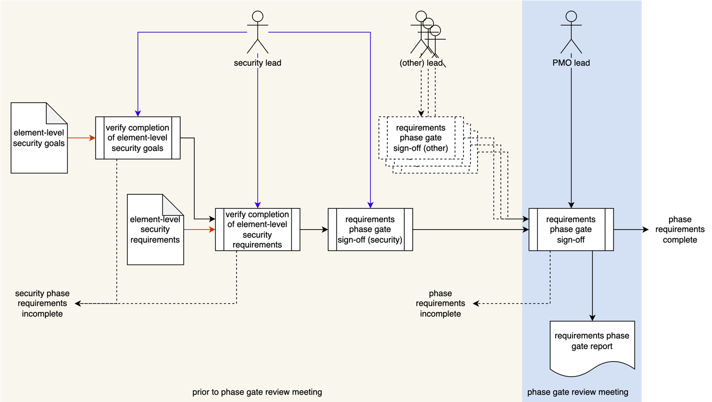

# Process

The following diagram is a taken from the requirements phase section of the **AVCDL** product dependencies graph.

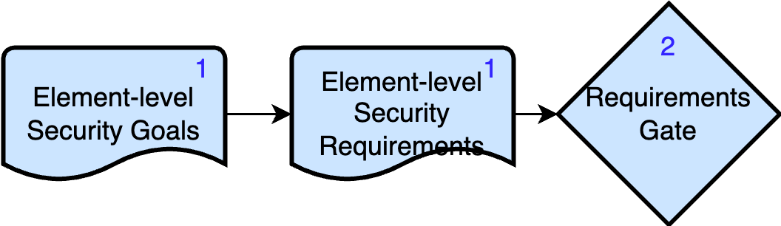

As shown by the blue numbers in the upper right corner of each element, we can see that the requirements phase gate has only one gated phase requirement with two products. The following phase requirement products need to be verified as completed for the gate to be signed off:

1. **Element-level Security Goals**
2. **Element-level Security Requirements**

The process is broadly divided into two parts: prior to the phase gate review meeting and the meeting itself. Activities taking place prior to the meeting are conducted separately by each group with a dependency on the gate. Failure during these activities precludes the meeting taking place, as any such failure would cause the gate to be failed.

## Element-level Security Goals Verification

|  |  |
| --- | --- |
| **Inputs** | Element-level Security Goals |
| **Outputs** | none |
| **Participants** | Security Lead |

The security lead verifies that the **Element-level Security Goals** phase requirements product for the element under consideration are complete. If they are not complete, the gate should not be entered and the PMO should be informed.

## Element-level Security Requirements Verification

|  |  |
| --- | --- |
| **Inputs** | Element-level Security Requirements |
| **Outputs** | none |
| **Participants** | Security Lead |

The security lead verifies that the **Element-level Security Requirements** phase requirements product for the element under consideration are complete. If they are not complete, the gate should not be entered and the PMO should be informed.

## Requirements Phase Gate Signoff (Security)

|  |  |
| --- | --- |
| **Inputs** | none |
| **Outputs** | none |
| **Participants** | Security Lead |

The security lead signs off that all security-related products for this phase are complete and in good order. The PMO is informed of this.

## Requirements Phase Gate Signoff

|  |  |
| --- | --- |
| **Inputs** | none |
| **Outputs** | Requirements Phase Gate Report |
| **Participants** | PMO Lead |

If all participating groups provide signoffs the phase gate review meeting takes place. During this meeting all parties satisfy themselves that all their dependencies upon other groups are met. If there are no issues raised, the PMO lead signs off that all products for this phase are complete and in good order. Otherwise, the gate is not passed. The PMO produces the **Requirements Phase Gate Report** to document the gate outcome.

At a minimum, the report contains formal sign-off from each group’s lead with a list of the phase products verified.

# References

1. **AVCDL** Product Dependencies (in **AVCDL** main document)
2. **Requirements Phase Gate Report**
3. **Element-level Security Goals** (**AVCDL** secondary document)
4. **Element-level Security Requirements** (**AVCDL** secondary document)